NOTICE OF ELECTION

Hazlerigg Parish Council
Election of Councillors
Parish | Number of Councillors to be elected
Hazlerigg | Eight

1. Nomination papers must be delivered to the Returning Officer at Civic Centre, Newcastle upon Tyne, NE1 8QH between 9.00 am and 4.00 pm on any working day from the date of publication of this notice (excluding bank holidays) but no later than 4pm on Tuesday 4 April.

2. Nomination papers may be obtained from the offices of the Returning Officer, Civic Centre, Newcastle upon Tyne, NE1 8QH during the times stated above.

- If any election is contested the poll will take place on Thursday 4 May 2023.

- Applications to register to vote must reach the Electoral Registration Officer by 12 midnight on Monday 17 April 2023. Applications can be made online: https://www.gov.uk/register-to-vote.

5. Applications, amendments or cancellations of postal votes must reach the Electoral Registration Officer at Civic Centre, Newcastle upon Tyne, NE1 8QH by 5 pm on Tuesday 18 April.

6. Applications for a Voter Authority Certificate or an Anonymous Elector’s Document valid for this election must reach the Electoral Registration Officer by 5pm on Tuesday 25 April. Applications for a Voter Authority Certificate can be made online: https://www.gov.uk/apply-for-photo-id-voter-authority-certificate

7. Applications to vote by proxy at this election must reach the Electoral Registration Officer at: Civic Centre, Newcastle upon Tyne, NE1 8QH by 5 pm on Tuesday 25 April.

8. Applications to vote by emergency proxy at this election must reach the Electoral Registration Officer at Civic Centre, Newcastle upon Tyne, NE1 8QH by 5 pm on Thursday 4 May.

 | 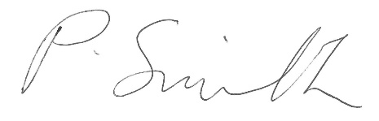
Dated: 24 March 2023 | Returning Officer

