NOTICE OF VACANCY

Newcastle City Council

CASUAL VACANCY

IN THE OFFICE OF COUNCILLOR

North Jesmond Ward

Notice is hereby given under Section 87(2) of the Local Government Act 1972 that a casual vacancy exists in the office of Councillor for the North Jesmond Ward of the City of Newcastle.

A by-election will be held upon receipt by the Returning Officer of two requests from local government electors within the local authority area. The date of a by-election will be determined by the Returning Officer but will be within 35 days, excluding dies non, of the required requests being received.

All requests must be sent to the Returning Officer, c/o Electoral Services, Civic Centre, Newcastle-upon-Tyne, NE1 8QH.

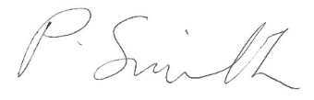

Pam Smith
Returning Officer

Date: 24 March 2023

Printed and published by the Returning Officer, CIVIC CENTRE, NEWCASTLE UPON TYNE, NE1 8QH

