Submitting an application - City Centre Resident permit

- After creating an account (if you haven’t done this, please see the guide found linked here – Resident Parking Permits | Newcastle City Council). You can log in to your account by clicking “Customer Register/Sign in” button

- Enter the email address and password that was used to create your account and click “sign in”

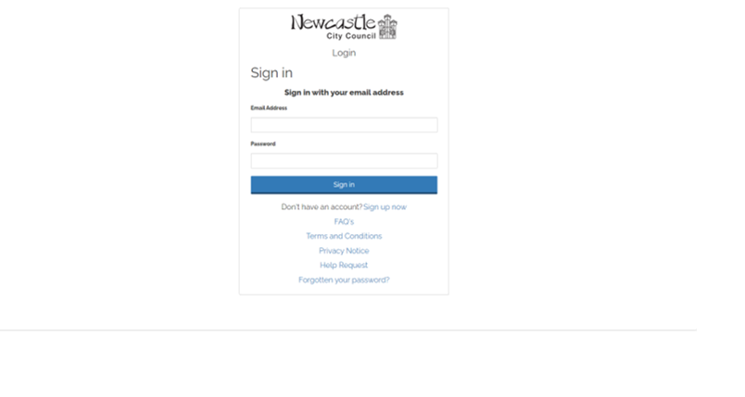

- After logging in, you will come to the Citizen Hub home page, as shown below
- To submit a Resident Permit Application, click “Make a New Application” heading in the top left as per above.
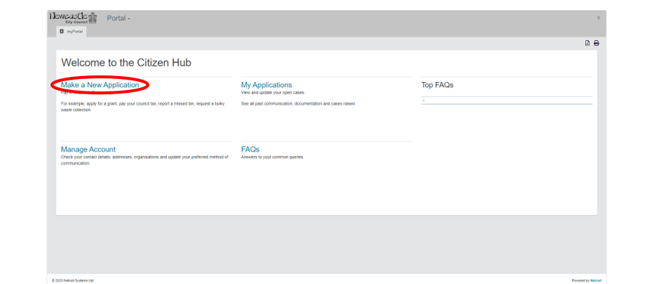

- You will then be taken to a new page.
- From the list on the right-hand side, click “Parking Services – City centre Resident permit”

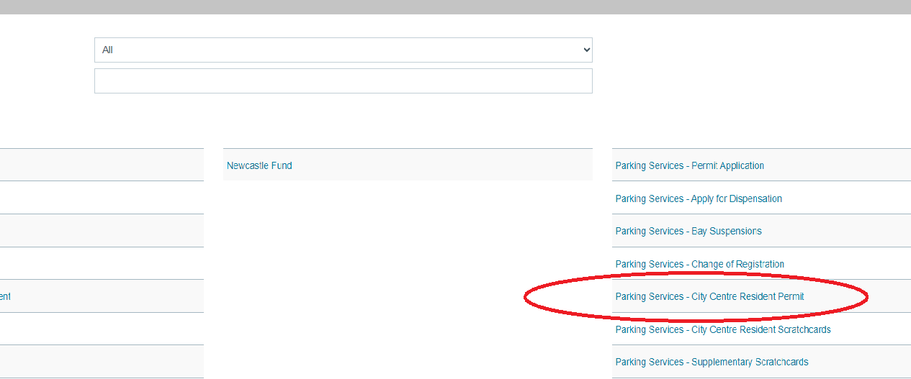

- You will then be taken to the below screen
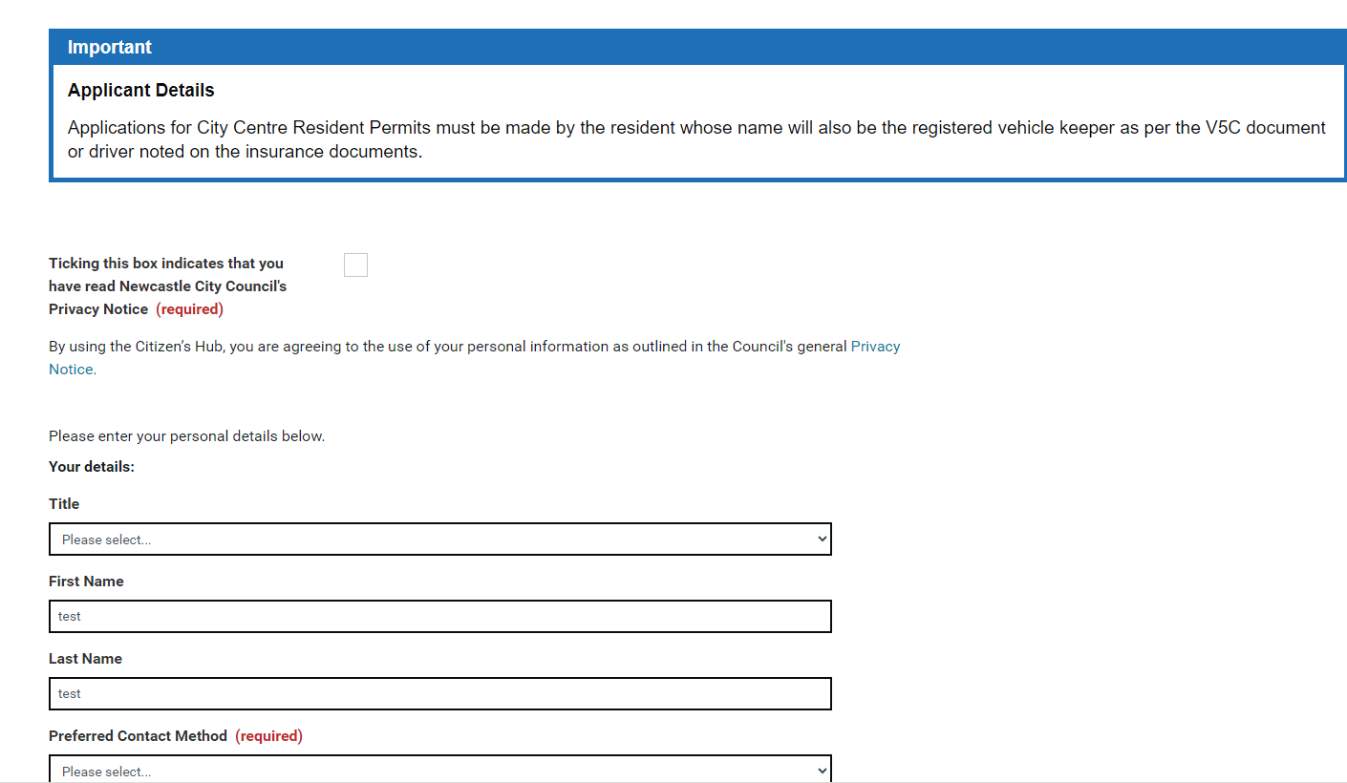
- There is a Privacy notice link highlighted in blue which will take you to the privacy notice information page which you can read through. Ticking this box indicates that you have read the privacy notice.
- Fill in personal details like name, contact number and email address and address.
- Once completed, click the “Continue” button.

- The application must be submitted by the resident.
This permit entitles a resident who lives within the city centre meter zone to park in any pay and display bay on-street near their home or in any pay and display bays within Council operated car parks in the city centre. The permit will be valid 24 hours, 7 days per week. The permit does not provide exemptions for the following types of bay: electric vehicle charging bays; loading bays; disabled bays; taxi bays; pedal cycle bays; bays within resident permit parking schemes; Citypark permit bays or car club bays.
- Enter the permit duration which can be
- 4 weeks
- 6 months
- 12 months

- Enter the vehicle registration number
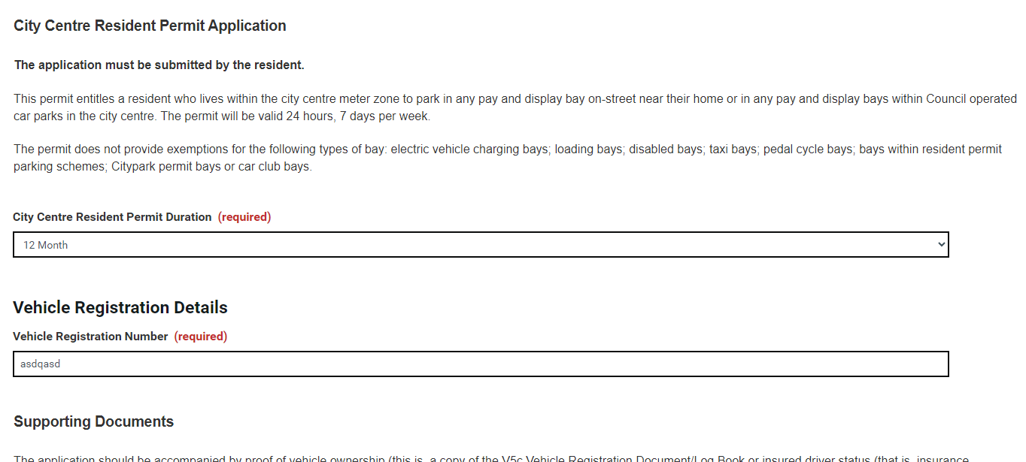

- Upload the proof of address (current tenancy agreement, council tax bill for this financial year or bank statement/utility bill dated in last 3 months).
- Upload Proof of Vehicle Ownership;( Hire/Lease Agrement or Insurance Schedule )
- Click Continue

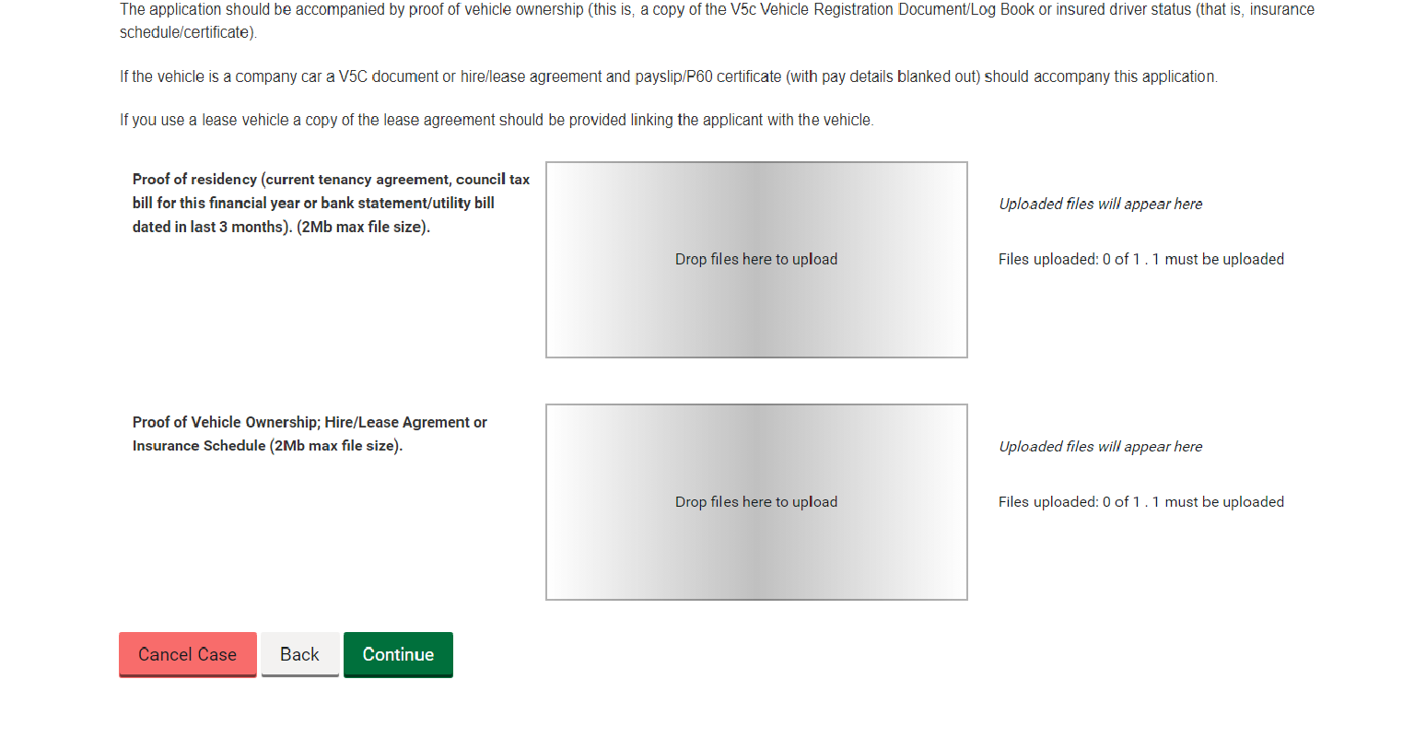
- You will then be taken to the final section of the Application Form.

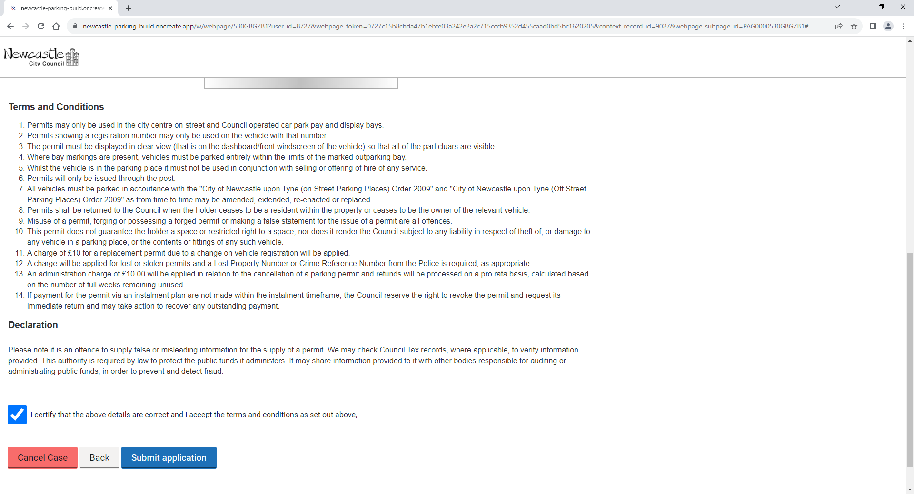

- Please read the terms and conditions and the declaration, once these have been read and understood, if you agree to accept the terms and conditions, click the box
- You can then click the “Submit application” button.

