Submitting an application – resident permit
- After creating an account (if you haven’t done this, please see the guide found here – link to ………….) you can log in to your account by clicking “Customer Register/Sign in” button
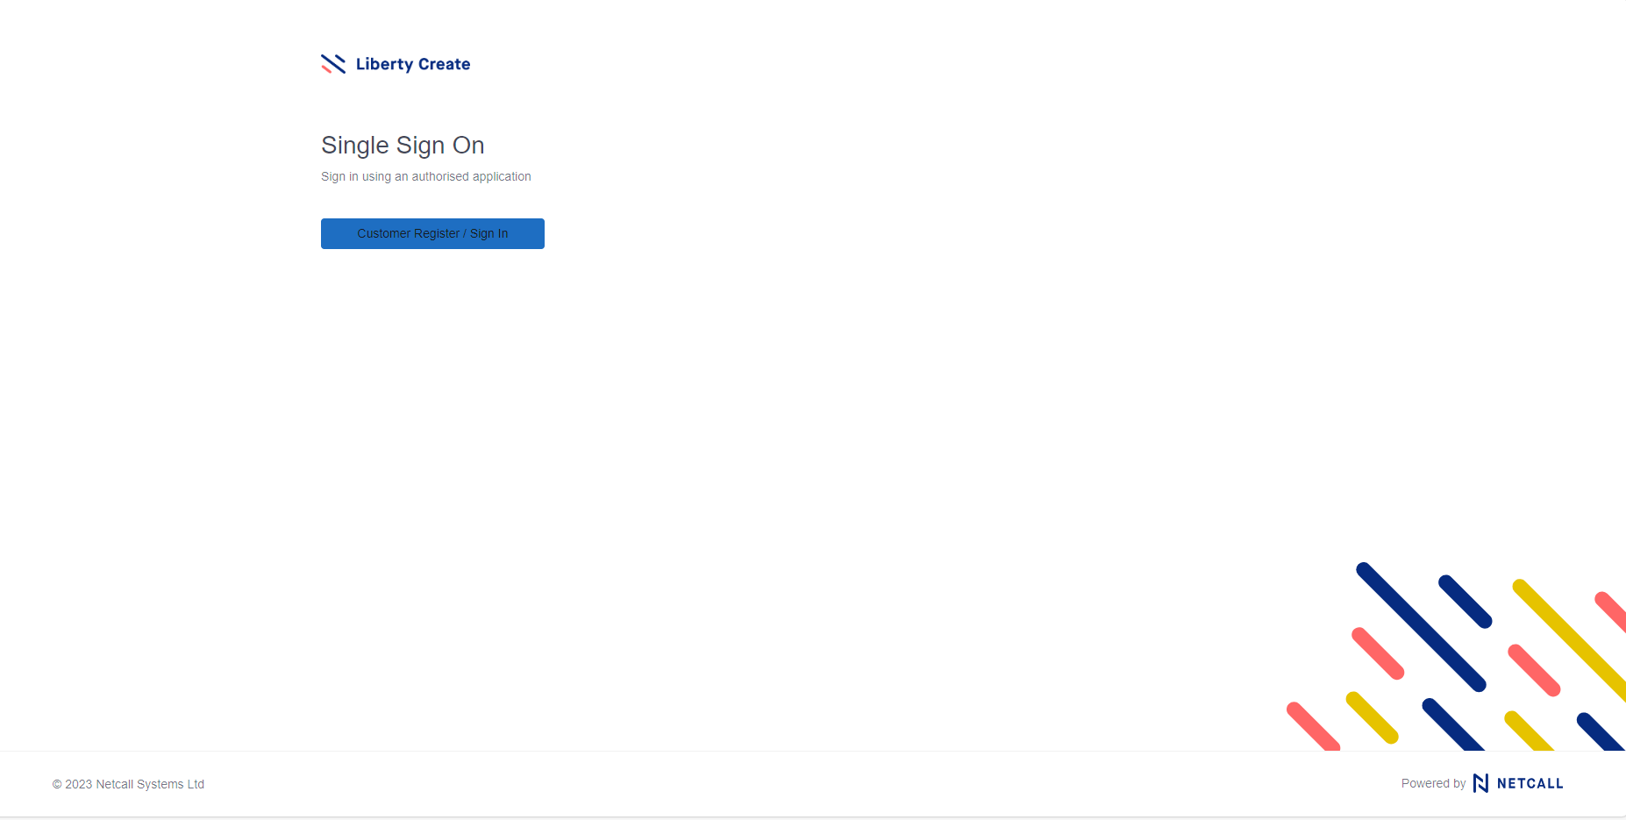
- Enter the email address and password that was used to create your account and click “sign in”
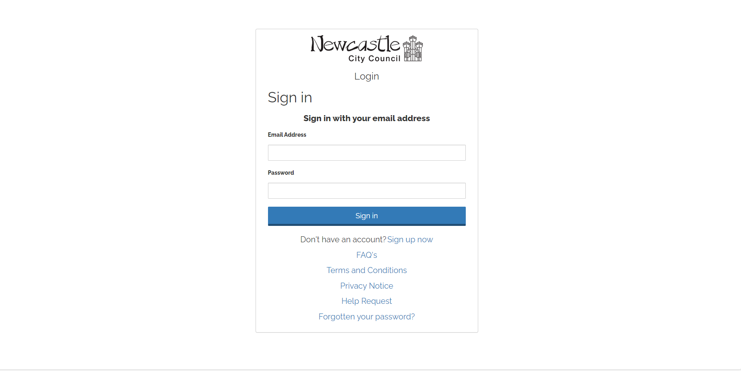

- After logging in, you will come to the Citizen Hub home page, as shown below
- To submit a Resident Permit Application, click “Make a New Application” heading in the top left as per above.

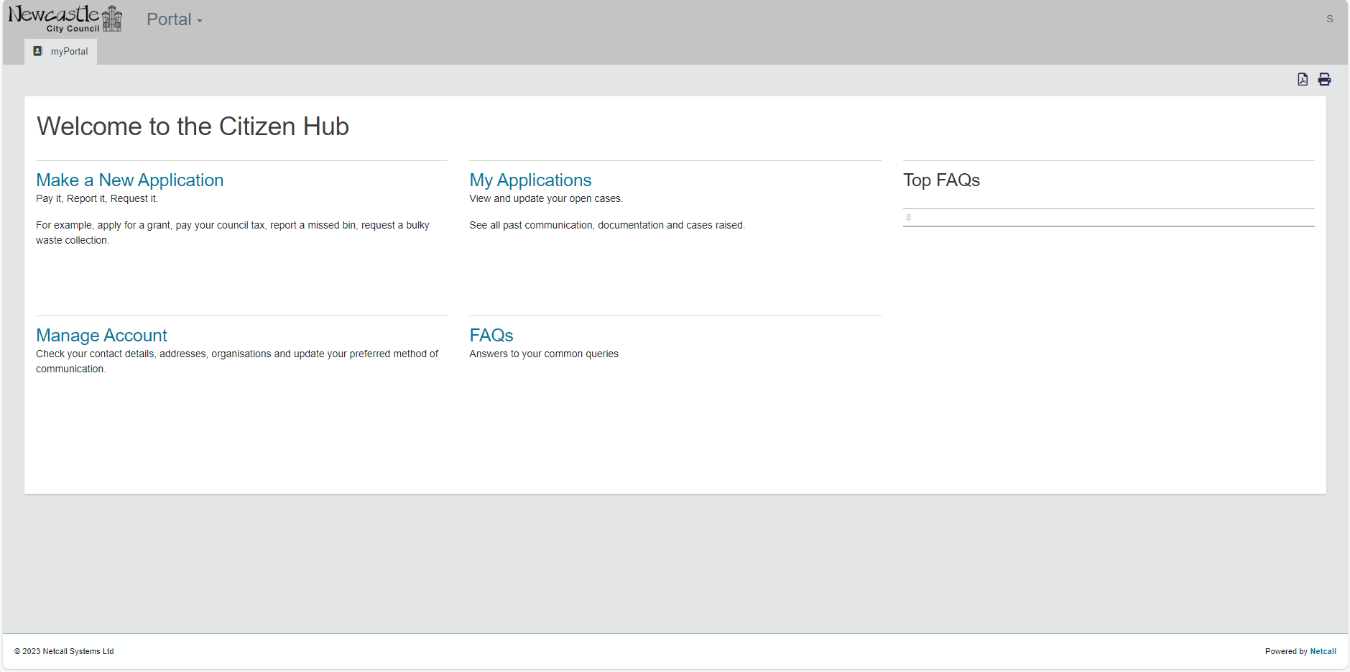
- You will then be taken to a new page.
- From the list on the right-hand side, click “Parking Services – Permit Application”

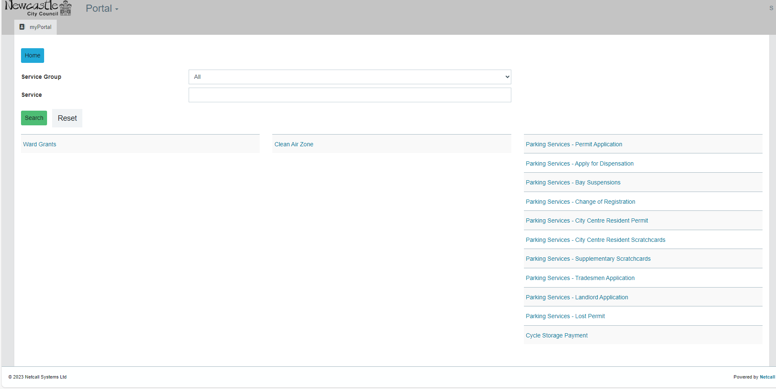

- You then be taken to the below screen
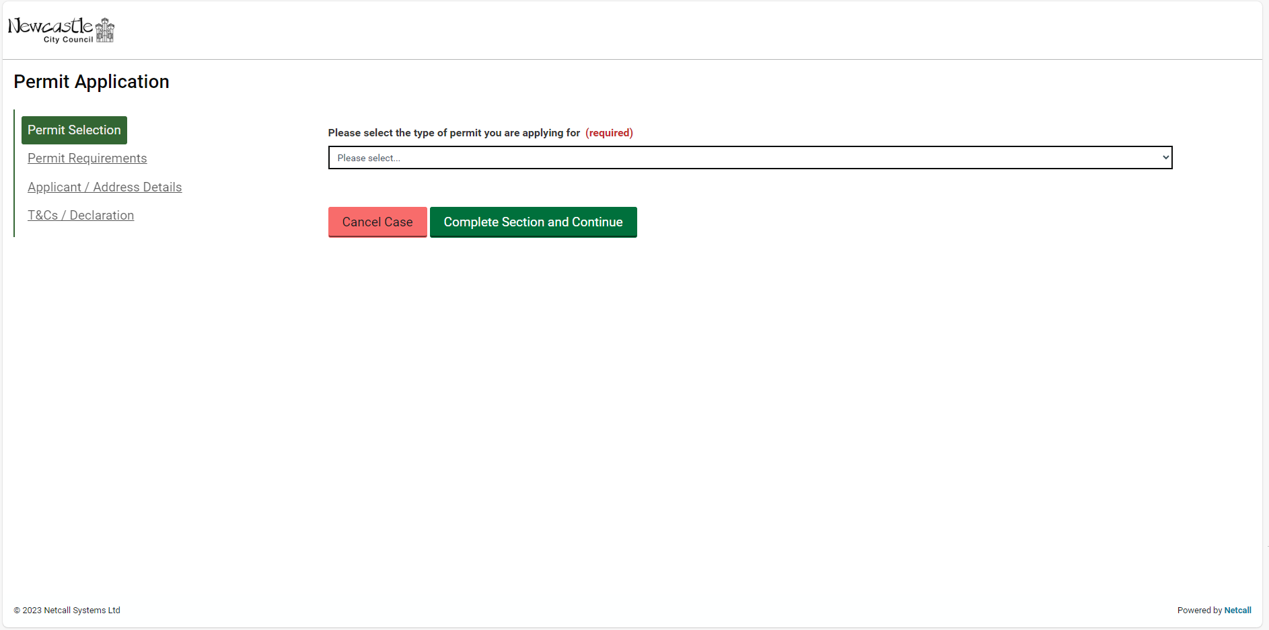
- From the dropdown box, please select the type of permit required and click “Complete Section and Continue” button

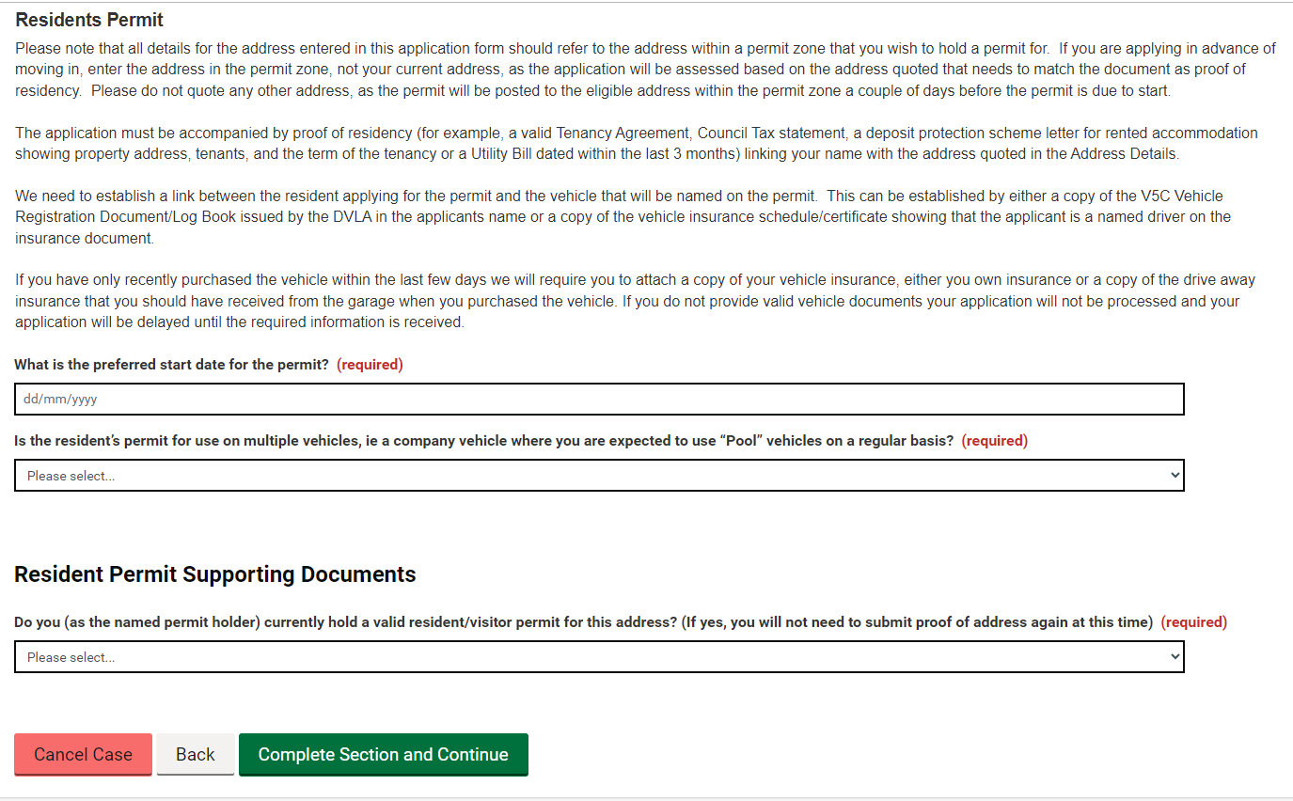
- Following this, there is some important information that needs to be read

- Select the preferred start date of the permit

- Select yes or no from the dropdown box to confirm if the permit is to be a Pool Permit
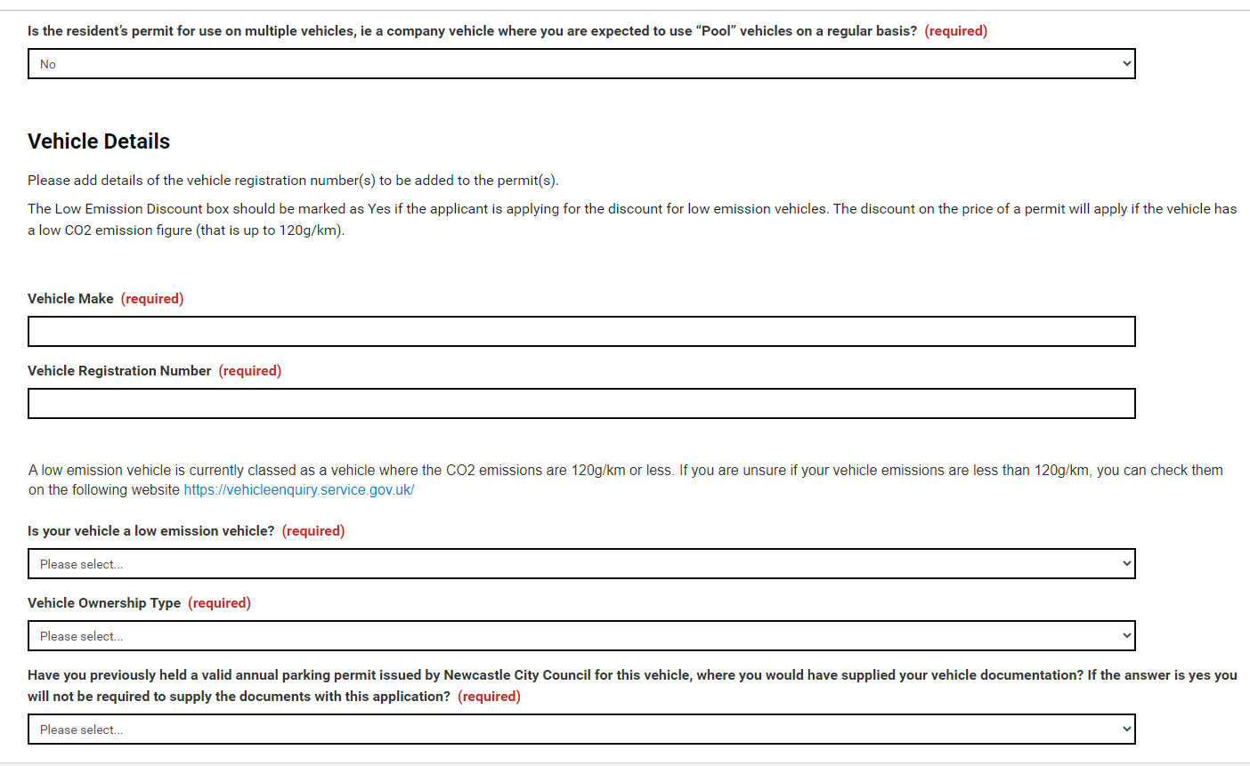
- Enter the vehicle make
- Enter the vehicle registration number
- Select yes or no from the dropdown box to confirm if the vehicle meets the low emission criteria
- Enter the vehicle ownership type e.g. Owned, Leased, Company car
- Select yes or no from the dropdown box to confirm if you have previously held a valid resident permit for this vehicle
- If no, you will need to upload your vehicle documents by dragging and dropping the file into the box or clicking the box and selecting the document from the files on your device
- Select yes or no from the dropdown box to confirm if you are a current permit holder at the address that you are applying for.
- If no, you will need to upload your proof of address document by dragging and dropping the file into the box or clicking the box and selecting the document from the files on your device and upload your vehicle documentation the same way
- If yes, you will need to enter the permit number
- Once any documents that are required have been uploaded, click “Complete Section and Continue”
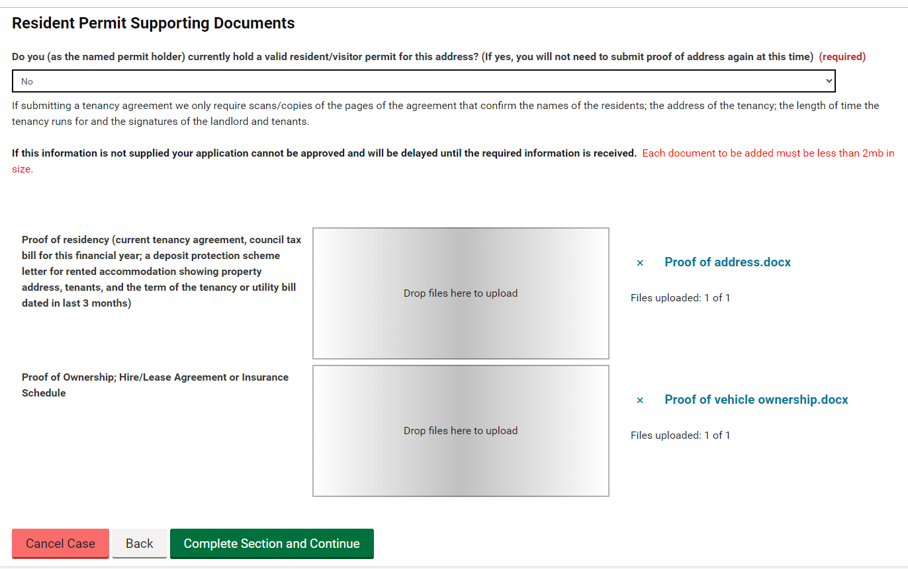

- You will then be taken to the below screen

- Please read the Policy Notice by clicking the link and once this has been read and understood, click the box.
- Complete the above sections with your personal details. Title, First name, Last name, Preferred contact method Email/Mobile, telephone number. Email Address and the permit address.
- Once completed, click the “Complete Section and Continue” button.
- You will then be taken to the final section of the Application Form.

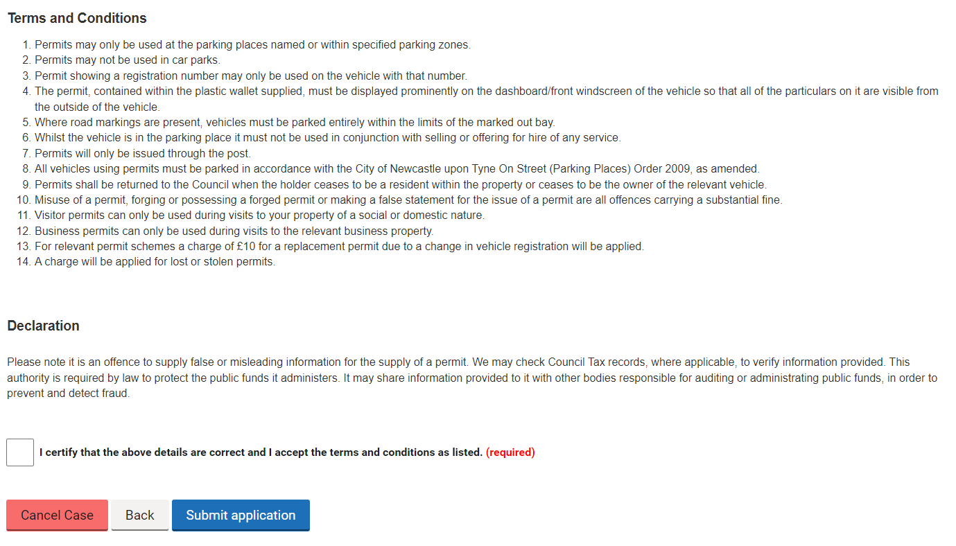
- Please read the terms and conditions and the declaration, once these have been read and understood, if you agree to accept the terms and conditions, click the box
- You can then click the “Submit application” button

