                - NEWCASTLE CITY COUNCIL BUILDING CONTROL

                - BUILDING REGULATION CHARGES – GUIDANCE NOTE 1
                - NEW BUILD HOUSING

                - With effect from 6th of April 2021

This information sheet provides a quick reference guide to finding the relevant charges for new build housing.

Full details are contained in Newcastle City Council’s ‘Scheme for the recovery of building regulation charges and associated matters’. This is published on the council’s website and contains full details of the charges scheme and the provisions of The Building (Local Authority Charges) Regulations 2010.

How to use the table to calculate your building regulation charge:

Full Plans Application -
- The Plan Charge is a deposit fee payable at the time of submitting a Full Plans application with the local authority.
- The Inspection Charge is the balance payment for the cost of the service, required to be paid on demand, after the first inspection has been carried out, following commencement of the works. The invoice for this charge will be sent to the owner (applicant on application form), unless requested otherwise.
- Alternatively, the customer my wish to pay a combined plan charge and inspection charge at the time of depositing the application, in which case the discounted charge as indicated would be payable.

Regularisation / Reversion Charge -
- This charge is payable at the time of depositing a Regularisation Application with the local authority.

Charges are subject to VAT with the exception of Regularisation / Reversion Applications.

How to pay:

Once we have received your application, we will email you with a link to make a credit or debit card payment online. Please note that until such time as the relevant payment has been made, your application will not be treated as valid.

Our standard charges have been set on the basis that:
- The inspection framework and approved plans (where relevant) should provide the local authority with reasonable evidence that your completed project complies with minimum Building Regulation requirements.
- The purpose of the service provided by Local Authority Building Control is to check as far is reasonably practicable, that Building Regulation requirements are satisfied. It must be appreciated that site visits only constitute a spot inspection.
- The inspection framework and fee charged for dealing with the building regulation application assumes that persons employed by the applicant to undertake the design and building work are competent. If you require a more extensive supervisory service of building work, you are advised to employ a suitably qualified person to carry this out on your behalf.
- The building work does not consist of, or include, innovative or high risk construction techniques and/or the duration of the building work from commencement to completion does not exceed 12 months.

Our standard charges do not cover building regulation applications for:
- Applications in excess of 10 new dwellings
- Dwellings with a floor area greater than 300m²
In any of these circumstances, please contact Building Control to determine the relevant charges for these applications.

Other charges/refunds:
- If the basis on which the charge has been determined changes, the Local Authority may refund or request a supplementary charge. The Authority will provide a written statement setting out the basis and method of calculation for the refund/supplementary charge.
- An additional charge of £400.00 + VAT is payable for work when the relevant building work, or part thereof, has not been carried out by a person referred to in regulation 7(5) (g) of (h) of the Building (Local Authority Charges) Regulations 2010. This is in addition to the inspection charge, building notice charge or regularisation charge.
- To resolve an outstanding case and issue a Completion Certificate where the work has been completed or occupied for more than 3 years from the date of the last inspection and a subsequent request is made for a Completion Certificate a charge of £157.50 + VAT will be applicable.
- Refunds - A fee of £52.50 + VAT will be charged for the withdrawal of a Building Regulation application prior to plan assessment being carried out and/or site inspection being made. Any refund on a Building Regulation application withdrawn after the local authority have begun the plan assessment and/or site visit(s) undertaken, will be at the discretion of the Council and on an individually determined basis.

Contact details:

Building Control
Newcastle City Council
Civic Centre
Newcastle upon Tyne
NE1 8QH
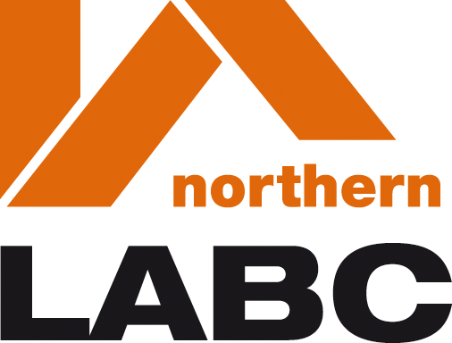
Phone: 0191 278 2845
Email: building.control@newcastle.gov.uk
www.newcastle.gov.uk

TABLE A
NEW BUILDING DWELLINGS
Number of Dwellings | Full Plans Application |  |  |  | Regularisation Charge  (no VAT) | Reversion  Charge  (no VAT)
 | Plan Charge  Excluding VAT | Plan Charge  Including  VAT | Inspection Charge  Excluding VAT | Inspection Charge  Including VAT
1  2  3  4  5  6  7  8  9  10 | £157.50  per house type | £189.00  per house type | £682.50  £1023.75  £1365.00  £2047.50  £2730.00  £3150.00  £3675.00  £4200.00  £4620.00  £5040.00  £262 For each additional dwelling over 10 units | £819.00  £1228.50  £1638.00  £2457.00  £3276.00  £3780.00  £4410.00  £5040.00  £5544.00  £6048.00  £314.40 For each additional dwelling over 10 units | £1470.00  £2278.50  £3123.75  £4551.75  £5979.75  £6961.50  £7166.25  £8190.00  £9056.25  £9922.50  Individually determined charge per dwelling over 10 units | £1470.00  £2278.50  £3123.75  £4551.75  £5979.75  £6961.50  £7166.25  £8190.00  £9056.25  £9922.50  Individually determined charge per dwelling over 10 units

