Mental Health

Market Position Statement

1. Introduction & Purpose
Newcastle City Council is committed to providing appropriate living places and to help people live independent, safe and active lives, offering flexible, high-quality support, connecting people to their communities and preventing admission into long term residential care or hospital.
We provide support for adults with needs eligible under the Care Act 2014 (or eligible needs under Section 117 of the Mental Health Act, where Newcastle City Council is the responsible local social services authority) who have mental health diagnosis, this may include those with a possible range of secondary diagnoses, neurodiversity or emerging personality traits, struggling to self-regulate their emotions, co-existing substance misuse and those who have committed offences or are at risk of offending.
This Market Position Statement (MPS) outlines the current Mental Health provision within the community, commissioning intentions, and future opportunities. It aims to support providers in planning and investing in sustainable adult social care services.
The MPS should be read in conjunction with our summary MPS statement ‘Commissioning for Adult Social Care’.

2. Commissioned Services
The Mental Health Support Options Framework provides a range of support options under two contracts: Mental Health Outreach and Social Inclusion, and Mental Health Supported Living, delivered under a flexible procurement agreement (FPA).
The providers registered on the framework are:
- Outreach and Social Inclusion: Aspire Healthcare, and Coquet Trust.
- Supported Living: Coquet Trust, Creative Support, Lifeways – SIL, MMAB Consulting, and New Vision Care.
The framework is valued at £3,704,419.82 annually, running from 12 May 2025 to 31 March 2028, with 2 x 12 months options to extend available for each contract. Each framework will re-open half-way through the initial contract period, to allow new Providers to apply and join the FPA.
In addition to the FPA, Newcastle City Council also commissions support for people with a mental health diagnosis under a range of existing contracts or individually on a spot purchase basis:
- Supported Living – Under the existing Housing with Care framework we currently fund care packages from our mental health budget in 8 different supported living schemes.
- Home Care - Under the Newcastle Home Care Framework, there is a spot purchasing arrangement for people who require support with more complex mental health needs. There are currently 21 providers who are able to provide this type of support.
- Residential Care - There are 9 specialist residential care homes registered to provide mental health related support. There are also 8 older person’s care homes with additional Mental Health specialism registration in Newcastle.
- Day care – In August 2025, there were 10 people who have a mental health diagnosis using commissioned day and community opportunities services. There are also spot purchased packages with 5 specialist providers.

3. Supply and Demand Analysis
In 2025 we undertook a review of the people who have mental health needs who are accommodated and supported by the homelessness prevention contract. This highlighted a number of people with extended stays of more than 2 years and further data analysis and comparison also showed a number of people receiving social care support in addition, or being eligible for adult social care support. We are working to ensure the commissioned service provider of the homelessness prevention contract engages with adult social care in relevant cases to ensure the accommodation and support offer remains appropriate.
The current community based day opportunities contract (delivered by Chain Reaction) is age limited (over 55) but it is also underused within the prevention/ low level support remit (see MPS Day Opportunities) so future commissioning will consider how it can better support people who have mental health needs.
We had previously identified a lack of provision within a specialist adult social care support offer for people with complex or fluctuating mental health needs, and limited housing with support/supported living provision in the City, including crisis availability, step-up and step-down licence options, and long-term tenancy settings. These gaps have in the main been addressed through the new framework and contract arrangements described above, but we continue to review and seek to build on our provision to ensure we are responding to local need.

The diagram below sets out our offer for people with a mental health diagnosis, and where we have identified areas for development.
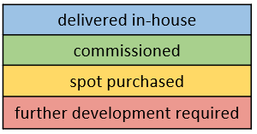

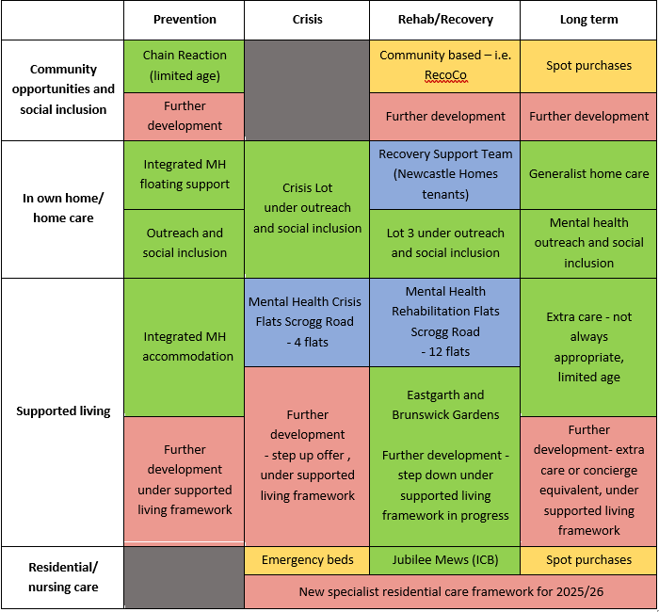

4. Needs Assessment

The Newcastle Joint Strategic Needs Analysis (JSNA) tells us that the population is ageing, with more residents living with long-term conditions and disabilities. The JSNA highlights the need for inclusive, responsive care that promotes independence and addresses health inequalities.
National priorities include promoting independence, reducing hospital admissions, supporting ageing in place, and integrating services. Locally, Newcastle City Council focuses on community-based support, preventative care and co-designed services.
In Newcastle, 18.7% of working age population is experiencing short or long-term common mental health issues, with additional 12% having personality or psychotic disorders (or two or more conditions). There has been an 9% increase in number of people experiencing mental health issues since 2014 and it is predicted this will increase further in next 20 years.
Substance misuse is the most associated mental health risk actor, and 4.43% of working age population is drug dependant (which is higher compared to 3.53% in the North East and same in England) and it is predicted to increase to 4.57% by 2040.
Excessive alcohol consumption can lead to dependency/ addiction, which in turn can impact on health and mental health; alcohol is one of the most common forms of ‘self-medication’ and 4% of working age people experience alcohol health related problems (compared to 4.3% of North East and 4.3% of England working age population) and it will remain at the same level with population increase.

5. Service Delivery Models

Current contract arrangements provide structure for a range of supported living options, encompassing existing services as well as creating opportunity for future settings to be brought under one contract.
Support is delivered as outreach - support at home, in the community and social inclusion, as well as supported living/housing with support schemes – currently within Eastgarth and Brunswick Garden schemes.
We are considering the following innovations or changes:
- Develop a continuum of mental health support inclusive of four key areas – prevention, crisis, rehab and recover as well as longer-term offer for people with mental health conditions living in the community (non-residential options)
- Build on what we already have to re-shape the existing offer and identify new opportunities and requirements, working with internal colleagues, providers, people and health partners to set further direction for commissioning
- Strengthen the community-based response to help people connect/re-connect with their communities, eliminating ongoing reliance on paid services
- Create a ‘wraparound’ offer for people to support them through their journey, at the right place in the right time, which would align with the 3 conversations model and include preventative approach, with providers and organisations across contact areas working together.
- Building future supported living schemes, to support expansion of the continuum of support.
We want to build on the positive experiences we already have, as well as expand the mental health support offer within Newcastle, to support people in a ‘joined up approach’, providing a more efficient structure within our current mental health support system, which will create the foundation for any future opportunities across Newcastle.
A joint approach through community, health, prevention and adult social care services will require development and the gathering of intelligence within the market; linking with providers and organisations through Newcastle Neighbourhoods and joint provider forums, to understand what is currently delivered under our contracts and available through health and community channels, to allow us to create more efficient and effective contract solutions.
We will strengthen the community-based response to help people connect/re-connect with their communities, and work to create a ‘wraparound’ offer for people to support them through their journey, at the right place in the right time, which would align with the 3 Conversations model and include preventative approaches, with providers and organisations working together.

6. Voice of People & Co-Production
Recent engagement with people with a mental health diagnosis in Newcastle has given some insights that should inform how services are delivered:
    - Stigma and Discrimination - The impact of stigma and discrimination is often felt more acutely than services realise
    - Social Connection and Inclusion - Social connections and community integration are critical but often overlooked
    - Different Journey Experiences - Different groups (e.g., young people, people with secondary needs, women) approach and experience mental health support and services very differently
    - Trauma Informed Approaches – Flexible, trauma-informed approaches are highly valued by people who use services
    - Complexity and System Navigation System - navigation and bureaucratic barriers remain significant challenges including:
- Frustration with having to repeatedly tell traumatic stories
- Language and cultural barriers create additional complexity
- Digital-by-default approaches can lead to exclusion
- Need for better coordination between services

7. Equality, Diversity & Inclusion (EDI)
Equality, Diversity & Inclusion (EDI) is embedded throughout the commissioning process and the Framework by:
- Designing services around neighbourhoods to reflect local diversity and needs.
- Promoting inclusive, person-centred care that respects cultural, emotional, and spiritual needs.
- Requiring providers to demonstrate flexible services that ensure equality of access for Newcastle’s diverse communities.
- Encouraging community involvement and co-design, ensuring services are shaped by those who use them.
Recent co-production work and research has highlighted the importance of approaches that recognise and respond to people's distinct identities and experiences. Providers are encouraged to consider how their co-production and service delivery approaches can be responsive to different identities and experiences.
Different groups may require approaches built around their specific needs and identities. Examples highlighted through local co-production include:
Young People
- Focus on education and employment pathways
- Support with transition to independence
- Age-appropriate peer support
- Different communication preferences
- Specific developmental needs
People whose first language is not English
- Language and cultural support needs
- Navigation of complex systems
- Cultural competency in service delivery
- Support with status transitions
- Community connection and integration

LGBTQ+ People
- Safe and affirming environments
- Understanding of specific vulnerabilities
- Recognition of chosen families/support networks
- Access to appropriate healthcare
- Protection from discrimination

Women:
- Create safer spaces for engagement
- Enable appropriate trauma-informed support
- Address specific barriers to accessing services

Neurodivergent people and people with Learning Disabilities
- Accessible communication
- Support with system navigation
- Recognition of vulnerability to exploitation
- Appropriate accommodation options
- Sustained support needs

8. Workforce & Market Sustainability
Workforce development
Newcastle City Council, in partnership with Newcastle City Learning, launched the Health and Social Care Academy to support recruitment and workforce development in the home care sector. The Academy aims to attract individuals with the right values and motivation to pursue a career in health and social care. Over the lifetime of the Home Care Framework, the Academy is expected to expand its offer, providing training opportunities for providers and contributing to sector-wide improvements in recruitment and staff retention. Providers are encouraged to engage with the Academy to strengthen their workforce and benefit from tailored support and development resources.
As part of its workforce development strategy, Newcastle City Council expects providers to support apprenticeships; Apprenticeships are seen as a key route to building a skilled, competent, and values-driven workforce. By investing in apprenticeships, providers can enhance service quality, improve staff retention, and contribute to the long-term sustainability of the care sector.
Providers are also expected to structure training pathways. Providers must implement induction programmes aligned with Skills for Care standards and ensure ongoing professional development, including the achievement of the Level 2 Diploma in Health and Social Care.
Real Living Wage
From 1 April 2016, the Government introduced a new mandatory national living wage (NLW) for workers aged 25 and above. This was adjusted in April 2021 to include those workers aged 23 and above.
In November 2022, the Council gained Living Wage Accreditation from Living Wage Foundation as part of its commitment to fair pay and a decent wage. We hope to create a network of accredited employers in the city to make Newcastle a Real Living Wage City, by working with our markets to explore what adopting the Real Living Wage could mean for them and their employees.
The Living Wage Foundation’s Real Living Wage is the term used to describe what people need to live; the minimum hourly wage necessary for people working full time to afford housing, food, utilities, transport, health care, recreation, and other basic needs like clothing.
There are several benefits attributed to offering the Real Living Wage to employees, including better productivity, motivation, loyalty, and quality of service to customers.
There are also benefits to employers such as improving the reputation of the business, increasing motivation and retention rates for employees, helping differentiate themselves from others in their industry, and improved relations between managers and their staff.
More information about the Real Living Wage can be found at www.livingwage.org.uk.
Please see also: A real living wage city | Newcastle City Council.
9. Future Commissioning Intentions

The existing framework will reopen in Autumn 2026, to allow new providers to register on the framework, and to support market development.
There is also a plan for additional supported living schemes, included in the housing priority list, to be built or sourced from existing housing stock/repurposed in the next few years.
We will work collaboratively with providers across adult social care, prevention and health, as well as community organisations, to shape our future support offer.
These options will support the development of a continuum of support encompassing prevention, crisis, rehab and recover as well as longer-term offer for people with mental health conditions living in the community.

Organisations interested in joining the existing Framework, and applying for future contracts, should register on OPEN portal www.open-uk.org
10. Legislation & Policy Context
- The Care Act 2014
- Care and Support Statutory Guidance issued under the Care Act 2014
- The National Health Service Act 2006
- The Safeguarding Vulnerable Groups Act 2006 and the Protection of Freedoms Bill
- The Health and Social Care Act 2012
- The Young Carers (Needs Assessments) Regulations 2015
- The Equality Act 2010
- The Health and Safety at Work Act 1974
- The Department of Education: Working Together to Safeguard Children 2018
- The NHS Outcomes Framework
- NHS Long Term Plan
- Mental Capacity Act 2005
- Human rights act 1998
- Mental Health Act 1983 (amended 2007)
- Modern Slavery Act 2015
- No Health Without Mental Health: a cross-government outcomes strategy
- Prevention Concordat for Better Mental Health
- Draft Mental Health Bill 2022
- Reforming the Mental Health Act: government response
- TLAP response to White Paper Reforming the Mental Health Act
- Mental health and wellbeing plan: discussion paper and call for evidence - results
- Better mental health support for people in crisis
- What-Good-Public-Mental-Health-Looks-Like

